NCWorks **Partnership** Conference

**Sponsors & Exhibitors Form**

**Partnership Conference**

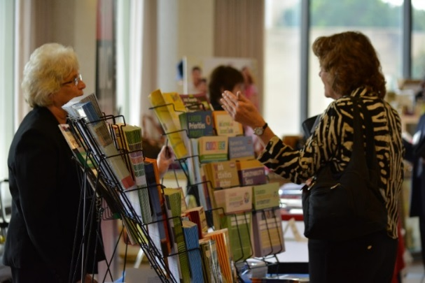



**Join North Carolina workforce development professionals at the**

**NCWorks Partnership Conference!**

October 10 – 12, 2018

Sheraton Four Seasons/Koury Convention Center

Greensboro, NC

*Celebrating the 31st Conference!*

**For Additional Information Contact –**

NCWorks Training Center

4351 Mail Service Center, Raleigh 27699

**Colette Trombley**

Phone: 919-814-0381 ● Fax: 919-329-5599

Email: [colette.trombley@nccommerce.com](mailto:colette.trombley@nccommerce.com)

**Robbin Broome**

Phone: 919-306-1819 ● Fax: 919-329-5599

Email: [robbin.broome@nccommerce.com](mailto:robbin.broome@nccommerce.com)

Sponsorship Opportunities

Conference sponsorship enhances your business visibility for products and services! Showcase your business by choosing one of the options below and joining over 1,000 North Carolina workforce development professionals in October.

Would you like to sponsor a speaker, meal, reception or discuss another option?

Contact Colette Trombley at 919-814-0381 or Robbin Broome at 919-306-1819.

**A sample of the options to promote your product or business are listed below!**

|  |  |  |  |  |  |  |  |  |
| --- | --- | --- | --- | --- | --- | --- | --- | --- |
|  | **Investment** | **Exhibitor Booth** | **Complimentary**  **Conference Registration** | **Company Logo on**  **Conference Website** | **Ad in Conference Program\***  ***August 17, 2018 Registration Deadline*** | **On-site Signage**  **at Conference** | **Printed Materials Distributed to All Conference Attendees** | **Priority Seating at**  **Awards Banquet** |
| **Gold Sponsorship** | $5,000 | http://www.clipartbest.com/cliparts/niE/LL8/niELL86iA.png | 4 | http://www.clipartbest.com/cliparts/niE/LL8/niELL86iA.png | Full Page | http://www.clipartbest.com/cliparts/niE/LL8/niELL86iA.png | http://www.clipartbest.com/cliparts/niE/LL8/niELL86iA.png | http://www.clipartbest.com/cliparts/niE/LL8/niELL86iA.png |
| **Silver Sponsorship** | $2,500 | http://www.clipartbest.com/cliparts/niE/LL8/niELL86iA.png | 2 | http://www.clipartbest.com/cliparts/niE/LL8/niELL86iA.png | Half Page | http://www.clipartbest.com/cliparts/niE/LL8/niELL86iA.png | http://www.clipartbest.com/cliparts/niE/LL8/niELL86iA.png | http://www.clipartbest.com/cliparts/niE/LL8/niELL86iA.png |
| **Bronze Sponsorship** | $1,500 | http://www.clipartbest.com/cliparts/niE/LL8/niELL86iA.png | 1 | http://www.clipartbest.com/cliparts/niE/LL8/niELL86iA.png | Quarter Page | http://www.clipartbest.com/cliparts/niE/LL8/niELL86iA.png |  |  |
| **Exhibitor Only** | $700 | http://www.clipartbest.com/cliparts/niE/LL8/niELL86iA.png | 1 | http://www.clipartbest.com/cliparts/niE/LL8/niELL86iA.png |  |  |  |  |

**accommodations**

**Hotel Registration Deadline**

September 10, 2018

 Conference Hotel Rate - $140 (plus $17.85 tax)

**Sheraton Four Seasons Hotel**

800-242-6556

www.sheratongreensboro.com

**EXHIBIT TIMES**

**Wednesday, October 10**

9:00 am—6:00 pm

**Thursday, October 11**

8:00 am—4:00 pm

**SPONSOR & EXHIBITOR**

**2018 REGISTRATION FORM**

|  |  |  |  |
| --- | --- | --- | --- |
| Company/Agency: |  | | |
| Representative Name: |  | | |
| Address/City/State/Zip: |  | | |
| Phone: |  | Email: |  |

**Sponsor Deadline of August 17th to enable Ad placement in Conference Program**

|  |  |  |  |  |
| --- | --- | --- | --- | --- |
|  | **Sponsorship Level – (includes Exhibitor Booth)** | | **Amount** | |
| **Gold Sponsor** -- $5,000 | | |  | |
| **Silver Sponsor** -- $2,500 | | |  | |
| **Bronze Sponsor** -- $1,500 | | |  | |
| **Exhibitor Only** | |
| Private Business--$700 discounted rate | |  | |
| **Private Business--$800 *after September 4th*** | |  | |
| Non-Profit/Government--$400 discounted rate | |  | |
| **Non-Profit/Government--$450 *after September 4th*** | |  | |
| **Additional Exhibitor Booth Options** | |
| YES  NO **Electricity--$90 (two days)** | | |  | |
| **Additional Representatives** | | | | |
| *Up to* ***two*** *additional representatives may attend at the reduced rate of* ***$200 each****.*  *List the names of additional representatives below.* | | | | |
|  | | **Amount** | |
| Additional Representative (s)  Name_____________________________________________  Name_____________________________________________ | |  | |
|  | |
| **Total** | |  | |

Make Checks Payable to: **NC Department of Commerce/Workforce** (45-5336839)

Mail to: **NCWorks Training Center-Sponsor/Exhibitor**

**4351 Mail Service Center, Raleigh, NC 27699-4351**

Phone: 919-814-0381 ● email: colette.trombley@nccommerce.com

Phone: 919-306-1819 ● email: robbin.broome@nccommerce.com