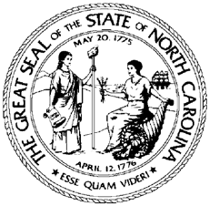 | NCWorks Commission
 | NCWorks Commission Policy Statement Number: CPS 01-2023
 | Date: February 8, 2023
 | Subject: Updates to Local and Regional Area Plan Instructions for Program Year (PY) 2023
From:

DRAFT
Tom B. Rabon, Jr.
Chair, NCWorks Commission

Purpose: | To transmit the N.C. Division of Workforce Solutions’ (DWS) Local and Regional Area Workforce Innovation and Opportunity Act (WIOA) Title I Plan Instructions for July 1, 2023 through June 30, 2024 (Program Year (PY) 2023).
Background: | North Carolina requires each Local Area Workforce Development Board (WDB), in partnership with the Chief Local Elected Official (CLEO), to annually review the Local Area Plan, board membership, and prepare and submit modifications to the Local Area Plan to reflect changes in labor market and economic conditions or other factors affecting the implementation of the Local Area Plan. [WIOA 108(a)]  The Local Area Plan will support the alignment strategy described in the 2020-2024 NC Unified State Plan in accordance with WIOA Section 102(b)(1)(E), and otherwise be consistent with the NC Unified State Plan.
Action: | Workforce Development Boards are to follow the attached instructions for development of Local Area Plan updates for July 1, 2023 through June 30, 2024.  Completed PY 2023 Local Area Plans are due to the DWS by May 5, 2023, and  are to be submitted in the Workforce Information System Enterprise (WISE).
Effective Date: | February 8, 2023
Expiration: | June 30, 2024
Contact: | DWS Planner
Attachments: | - PY 2023 Local Area Workforce Development Plan Instructions  - PY 2023 Plan Attachments

